Hero or Heroin Revisited

By: Greg Eastman

Introduction

By 2017 nine states had adopted legal recreational marijuana[1] laws and in the same year over 70,000 people died from opioids[2], this paper looks to see if these laws can decrease the proportion of people going to rehab for opium[3] addiction. This possibility of a connection comes from a medical and social founding, as cannabis is safe, can ease symptoms, and doesn’t require as much black-market access to obtain[4]. To get a causal estimate, this work employs two models, synthetic control, and stability-controlled quasi-experiment. Using these two strategies I find that recreational marijuana policy does not have a significant effect on the proportion of people admitted to treatment for opioid addiction.

Data

The data for this paper comes from the Treatment Episode Dataset – Admissions[5], a government record of individuals admitted to a rehab facility in a state/territory in a year. The data spans 48 states as well as Puerto-Rico and Washington DC. To gather the dataset all facilities that take any type of government funding are required to report admittance information on their operations. The original data was stratified at the individual level, but for the sake of this work it has been aggregated into a state/territory in a year as a single observation. Although there are missing values, like the state of Oregon, one of the nine legal states. To visualize how the data looks with these missing values, and counts of pre- and post-periods, the plot on the next page is provided using the gsynth r package[6].

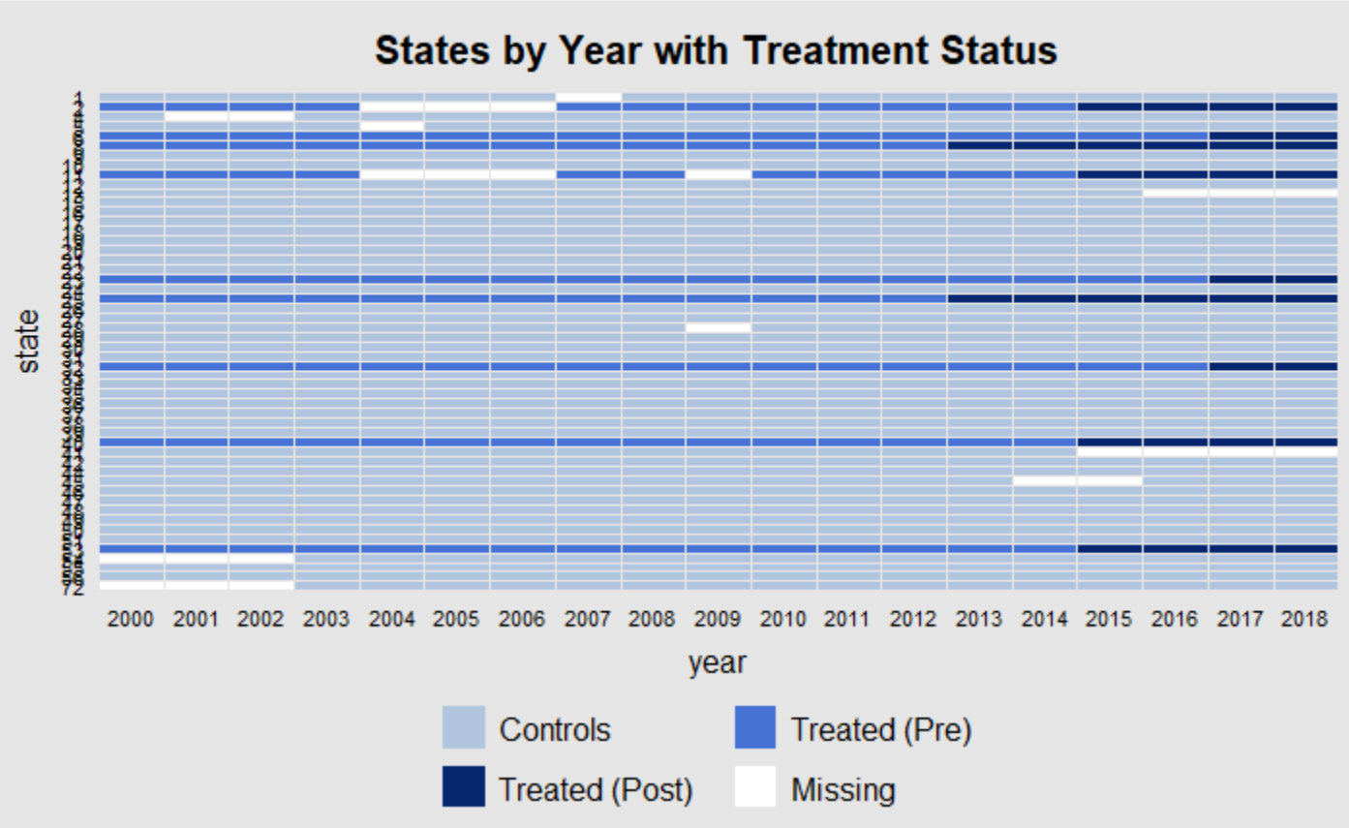

The missing values seem concerning, but even so there are nearly 1000 observations in total. So, it should not be an insurmountable issue. Now it is important to note two important assumptions made when using the data: external validity and lack of sample bias.

This data measures the proportion of admittance to rehab facilities for opioid addiction. This means that I am assuming that the admittance proportion holds some meaning for the rate of actual opioid addiction. The idea behind this is simple, as more people become addicted or become unable to manage it, more will go to rehab. As a single type of drug gains popularity over others, the percent admitted for it should increase in some proportion as well. The major worry about this assumption is that there could be a change in policy making rehab more attractive to people using opioids, like an increase in awareness of the dangers, or an increase in criminal sentencing. Although, because of the assumptions for the models that will be explained in the next section, this shouldn’t be an issue. This paper will therefore assert that it is looking at the proportion admitted to rehab and not the actual rate of addiction, but that this number is somewhat representative of actual addiction rates and is therefore meaningful. Although this data does raise some concerns to be addressed about possible sampling bias.

Only facilities that took government funding are required to report their admissions, but this should not be an issue because most facilities should take public money. Government funding is an economic benefit to these facilities, and not taking it would be a major inefficiency in their business model. Therefore, we can assume that the vast majority will be reporting and taking funding. Even so, the largest worry is that there is a subset of facilities that are systemic different in their reporting and admittance of opioid patients. This story doesn’t seem likely, as not taking funding shouldn’t encourage or discourage admitting more or less patients for opioid addiction. With possible internal and external bias accounted for, the next step is checking the data balance.

We are looking to see if the data is distributed consistently across the treatment and control groups. To check for differences the table below is provided as a reference.

|  |  |  |  |
| --- | --- | --- | --- |
|  | Mean Treatment | Mean Control | P-Value |
| Under-35 | .49 | .44 | 0 |
| White | .64 | .7 | 0 |
| Black | .16 | .17 | .73 |
| Other Minority | .2 | .13 | 0 |
| Advanced Degree | .2 | .23 | 0 |

These covariates are significantly different between groups, excluding the admittance of the black demographic. The largest disparity comes from the treatment group having a 5% whiter proportion of admittance than the controls. Although, these types of statical differences should not be an issue for this work. The assumptions for the methodology, which will be explained in more thoroughly in the next section, should ensure that the only difference that matters is if the demographics change when treatment happens. Since none of these covariates, even the most significantly different ones, should shift when marijuana legalization is enacted, the lack of balance is not an issue.

Methodology

The first model that this paper will use is a synthetic control[7]. This strategy expands on the idea of difference-in-differences by taking elements of matching techniques to relax the necessary assumptions. The method uses the pre-treatment period to weight the observations in the control group such that they track the treated group. In this sense you are making a synthetic counterfactual, a composite state/territory that tracks identically along with the treatment in the pre-period. Since this new “control” is made of weighted versions of untreated states/territories it should continue to follow identically even in the post period, except for the effect of the treatment. Therefore, if the assumptions discussed next are met, the difference between the fake control and actual control should be the causal estimate.

For synthetic control to work there is one major assumption made about the data, at the time of treatment the only affect that happens to the treated unit and not the control is the treatment. For this work I am assuming that nothing happens to a state/territory legalizing marijuana that does not also happen to some of the untreated states/territories when the law changes. Since cannabis law is not packaged with rehab laws or other influences, this assumption should be safe to make. Additionally, marijuana laws were implemented at different times. So, even if a state/territory’s marijuana law passed simultaneously with sweeping rehab changes, this would not likely be the case for all of the treated units. So synthetic control should have a solid foundation to get an estimate. Now, it’s time to look at the other method employed in this paper, SCQE.

Synthetic-controlled quasi-experiment[8] is a method that on the surface is using an instrumental-variable model with time as the instrument, but mechanically it allows for a less strict set of assumptions. This strategy gets the ATT by comparing expected value in the pre-period, to the difference in the post-legalization control and treated group. Although, unlike IV the researcher looks at a range of potential values of the outcome, a delta, and then argues whether the difference could have happened in the absence of treatment. This means that instead of assuming I have controlled for all exogenous variation, I look at how much variation I would need to have missed to change the result. Therefore, the researcher must argue that there is not enough bias present to alter their findings. Usually, the missing bias is signed and reasoned by an expert with knowledge in the field of study. In this paper’s case I did not have access to such an expert, as such I will use available knowledge and logical reasoning to justify my results. Beyond these justifications SCQE does have another requirement, there must be a statistically significant number of units that received treatment to avoid a weak instrument problem.

The proportion of states that have legalized marijuana compared to those that haven’t is low, to account for this I have adjusted the way the model will run on my data. Instead of looking at each state individually, or in cohorts of the states that adopted in a year, I perform the analysis on all treated states at the same time. This means that I will be comparing the year 2011, before any legalized, to 2017 a year after all the treated states in the data have legalized. This makes the standard errors go down, and the estimates be less influenced by small changes in delta. Although, the larger time gap between the periods, and some states having legalized in years prior, makes the justifications more challenging. Nonetheless this strategy is essential to avoid a weak instrument issue. With the methodology for both Synthetic Control and SCQE covered, the next step is to employ and analyze the models.

Results

We will begin by evaluating the synthetic control. For this analysis I used the gsynth package which allowed me to look at the data in two separate ways. The first was done by forming all the treatments and controls into two composits and looking at the general effects around the years of treatment.

On the left graph the blue dashed line is the composite control, and the solid black line is the treated group. We can see that the two lines do not follow each other exactly, but are close enough to notice any drastic trends, which are not present. The two lines do not diverge much at all in the treatment period. There is a slight change years after treatment, but it is small and could be from noise. Additionally, by three years after treatment, the two groups reconverge. So, to further explore the possible affect we look at the rightmost plot. There is not a significant change in the ATT, shown on the y-axis, across the treatment time. The value only dips slightly from years four to five, but otherwise stays at zero.

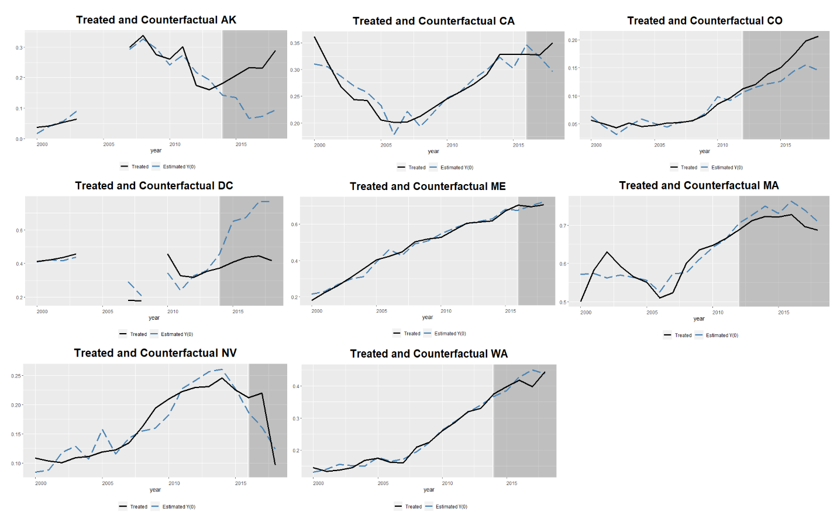 Those two plots imply that there is not an effect from marijuana legalization on the proportion of people admitted to rehab for opioid treatment. Although, to explore at a more granular level we employ a second strategy and plot each treated state/territory individually.

We note that most of the states/territories show no effect from treatment. The lines follow either at parallel or the changes are seen long after treatment. The only ones that showed a notable difference were Alaska, DC, and Colorado. The first two had missing data, which could mean that their counterfactual is off and creating a more drastic looking effect. Meanwhile, we see some change in Colorado, but it is in the opposite direction than is anticipated, and the effects aren’t seen until years after the treatment. This could mean that it is not actually the effect of treatment and is instead caused by a disparity from control not following the treatment closely after a few years of changes in Colorado. With both parts of the synthetic control in mind, it’s time to look at the results of the SCQE.

To look at the results of the stability-controlled quasi-experiment we will look at a plot made with the scqe r package[9], but before looking at the graph on the next page there are a few things to go over. First, it is worth remembering that the periods being compared are 2011 to 2017. In this interval 2 states legalized in 2012, 3 in 2014, and 3 in 2016. Therefore, 8 of 50 areas received treatment in total, which is small but should be a significant enough proportion to get reasonable estimates. Because of this grouped analysis there is likely to be a non-insignificant amount of variation to be reasoned through. With all this in mind the SCQE graph is on the next page.

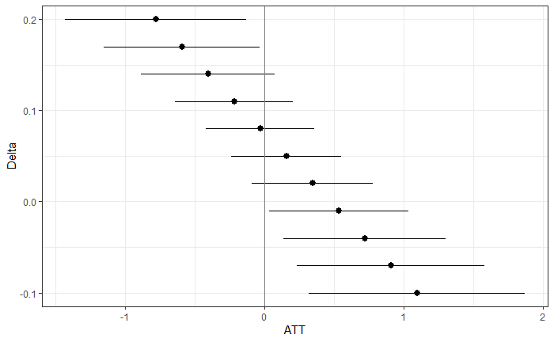

To start breaking down the information in the plot I will begin with what is needed for the policy to increase opioid treatments. For legalization to have the opposite effect than what we expect, the proportion of opioid admittance would need to have gone below zero. Although that might seem reasonable at first glance, it is not. The opioid crisis has only grown, and the proportion of people fighting their addiction has increased every year for the last two decades. This makes any number at or below zero infeasible. Therefore, we will look at what is needed for the proportion of admittees to go down because of legalization.

To have the hypothesized effect we can see that the proportion of admittances for opioid addiction would need to have gone up over 15 percentage points. This is also unlikely as it is not a 15% increase in addictions, it is in comparison to other drugs. Which are likely also going up. It is also only over a half-decade, not the 20-year period shown in the synthetic control. This shorter time span makes the large change highly unlikely. All in all, if the real increase is between 0 and 15%, we find that there is not a significant effect of cannabis policy on opioid admittance. To further reinforce this, I will look at the significance statistics from the SCQE.

To have a significant effect, the change in the outcome if treatment had not happened, would have needed to be above .319 or below -.159. Since the lower bound is not possible, given that proportion of opioid use is growing and not shrinking, we can assume that the policies did not increase the admittance proportions. On the other hand, a 30% increase in states that legalized is unlikely. That proportion is too high, even as fast as opioid addiction has grown. Essentially the reasoning used when analyzing the graph above apply here as well. We therefore have insubstantial evidence to reject the null hypothesis that marijuana policy has no effect on the proportion of people admitted to rehab for opioid addiction.

Conclusion

This paper’s findings did not align with its hypothesis, instead I fail to reject the null that there is no significant affect from marijuana legalization on the proportion of people admitted for opioid addiction. To get the best results I employed two separate inference strategies, synthetic control and SCQE. Both found no significant effect overall and at the state level the estimates varied heavily from one to the next, but none were meaningful. The two models gave the same result, and as both have different identifying assumptions and both have been well reasoned, the findings of no effect are strengthened. With this no result in mind, it’s time to look at the policy implications.

To get an idea of what marijuana policy does to the rate of opioid addiction, I got an estimate of the effect of legalization on the proportion admitted to rehab for opioids. The reasoning is that as the proportion of people going to rehab for a specific substance changes, so does the proportion addicted in the general population. Now this work failed to see a meaningful change from cannabis policy, so there is no evidence to assume that marijuana legalization is helping to alleviate the opioid crisis, nor is there any to show it is making it worse. All in all, this work sees the opioid epidemic as a non-factor when a state is considering whether it should legalize cannabis.

This work does note that it is not perfect, and there is room for improvement. The most obvious place to improve is having more states legalize to get more data with which to observe the effect. Other rooms for improvement are to cross reference this work with other metrics, like overdoses, to see if other societal outcomes are affected. Additionally, one of the main weaknesses of this paper is its reasoning for delta. Although justifiable by looking logically at available information, it is not an expert analysis, so consultation with someone more versed in the policy specifics could help to improve the identification strategy. These are just a few ways in which the exploration of policy implications of legalization and the opioid crisis can be further refined, nonetheless this work finds no significant link between the two.

1. Berke, Jeremy. "New Jersey Lawmakers Postponed a Critical Vote to Legalize Marijuana - Here Are All the State/territories Where Pot Is Legal." Business Insider. March 26, 2019. Accessed April 23, 2019. [https://www.businessinsider.com/legal-marijuana-state/territorys-2018-1](https://www.businessinsider.com/legal-marijuana-states-2018-1).
2. National Institute on Drug Abuse. "Overdose Death Rates." NIDA. January 29, 2019. Accessed April 23, 2019. <https://www.drugabuse.gov/related-topics/trends-statistics/overdose-death-rates>.
3. This paper is defining the term opium as meaning the same as opioid.
4. Yasmin L. Hurd,

   Cannabidiol: Swinging the Marijuana Pendulum From ‘Weed’ to Medication to Treat the Opioid Epidemic,

   Trends in Neurosciences, Volume 40, Issue 3,2017,Pages 124-127, ISSN 0166-2236, https://doi.org/10.1016/j.tins.2016.12.006.

   (<http://www.sciencedirect.com/science/article/pii/S0166223617300012>) Abstract: Epidemics require a paradigm shift in thinking about all possible solutions. The rapidly changing sociopolitical marijuana landscape provides a foundation for the therapeutic development of medicinal cannabidiol to address the current opioid abuse crisis.
5. "Treatment Episode Data Set: Admissions (TEDS-A)." Treatment Episode Data Set: Admissions (TEDS-A) | SAMHDA. Accessed December 09, 2020. <https://www.datafiles.samhsa.gov/study-series/treatment-episode-data-set-admissions-teds-nid13518>.
6. Gsynth: Generalized Synthetic Control Method. Accessed December 09, 2020. https://yiqingxu.org/software/gsynth/gsynth_examples.html.
7. lberto Abadie, Alexis Diamond & Jens Hainmueller (2010) Synthetic Control Methods for Comparative Case Studies: Estimating the Effect of California’s Tobacco Control Program, Journal of the American Statistical Association, 105:490, 493-505, DOI: [10.1198/jasa.2009.ap08746](https://doi.org/10.1198/jasa.2009.ap08746)
8. Chad Hazlett, David Ami Wulf, Bogdan Pasaniuc, Onyebuchi Arah, Kristine M Erlandson, Brian T Montague Credible learning of hydroxychloroquine and dexamethasone effects on COVID-19 mortality outside of randomized trials, medRxiv 2020.12.06.20244798; doi: https://doi.org/10.1101/2020.12.06.20244798
9. Chadhazlett. "Chadhazlett/scqe: Stability Controlled Quasi-Experimentation Version 0.0.0.9000 from GitHub." Version 0.0.0.9000 from GitHub. November 15, 2020. Accessed December 09, 2020. https://rdrr.io/github/chadhazlett/scqe/.